AutoIT/Robot

First screenshot explains how to write AutoIT script using AutoIT editor. And Save the file.

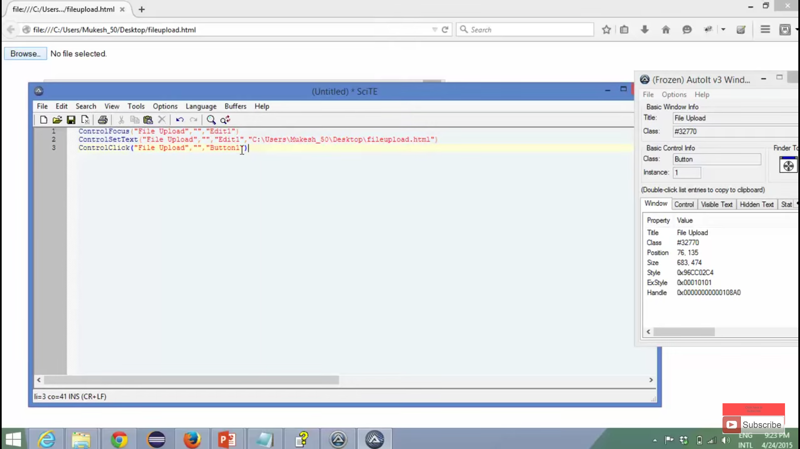

Second screenshot explains compiling AutoIT script using Win64 compile option. Right click on the AutoIT script for the option.

Note: After compile it creates exe file. This we can use in Selenium to upload file. If you double click on the file, if file upload opened, it will upload the file.

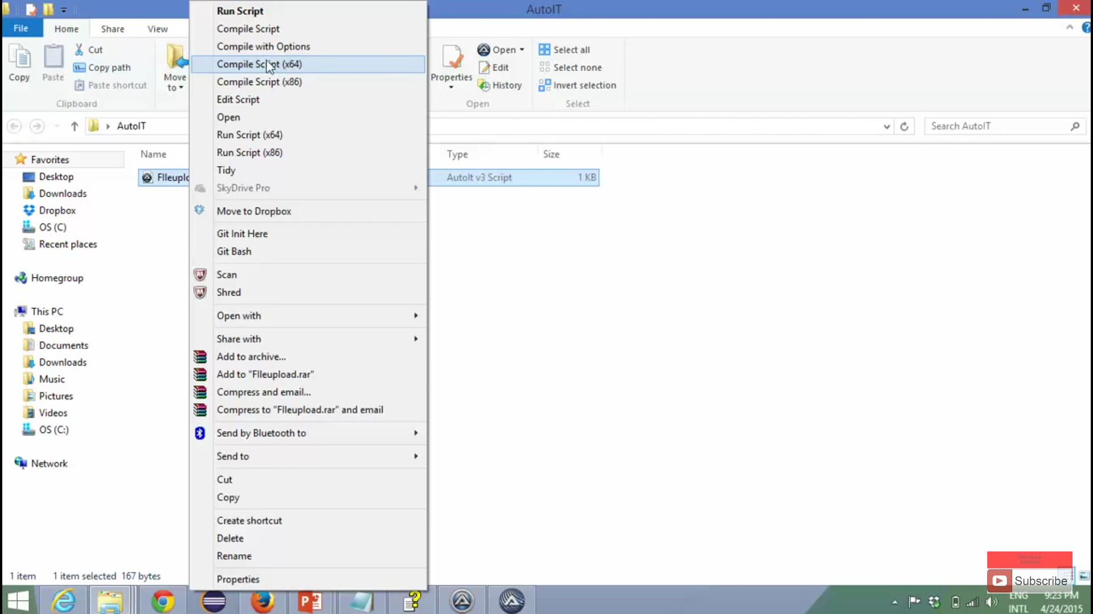

Third screenshot explains how to upload file thru selenium.

Note: Runtime get some checked exception. Add ioexception

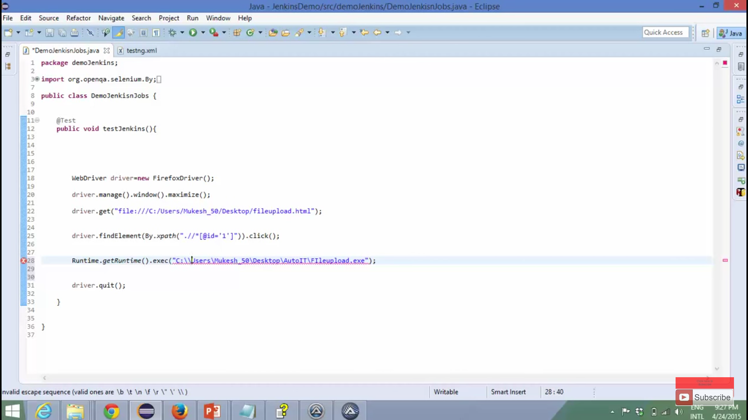

±++++++++++++++++++++++++++

Forth screenshot explains, File download script. Just two lines.

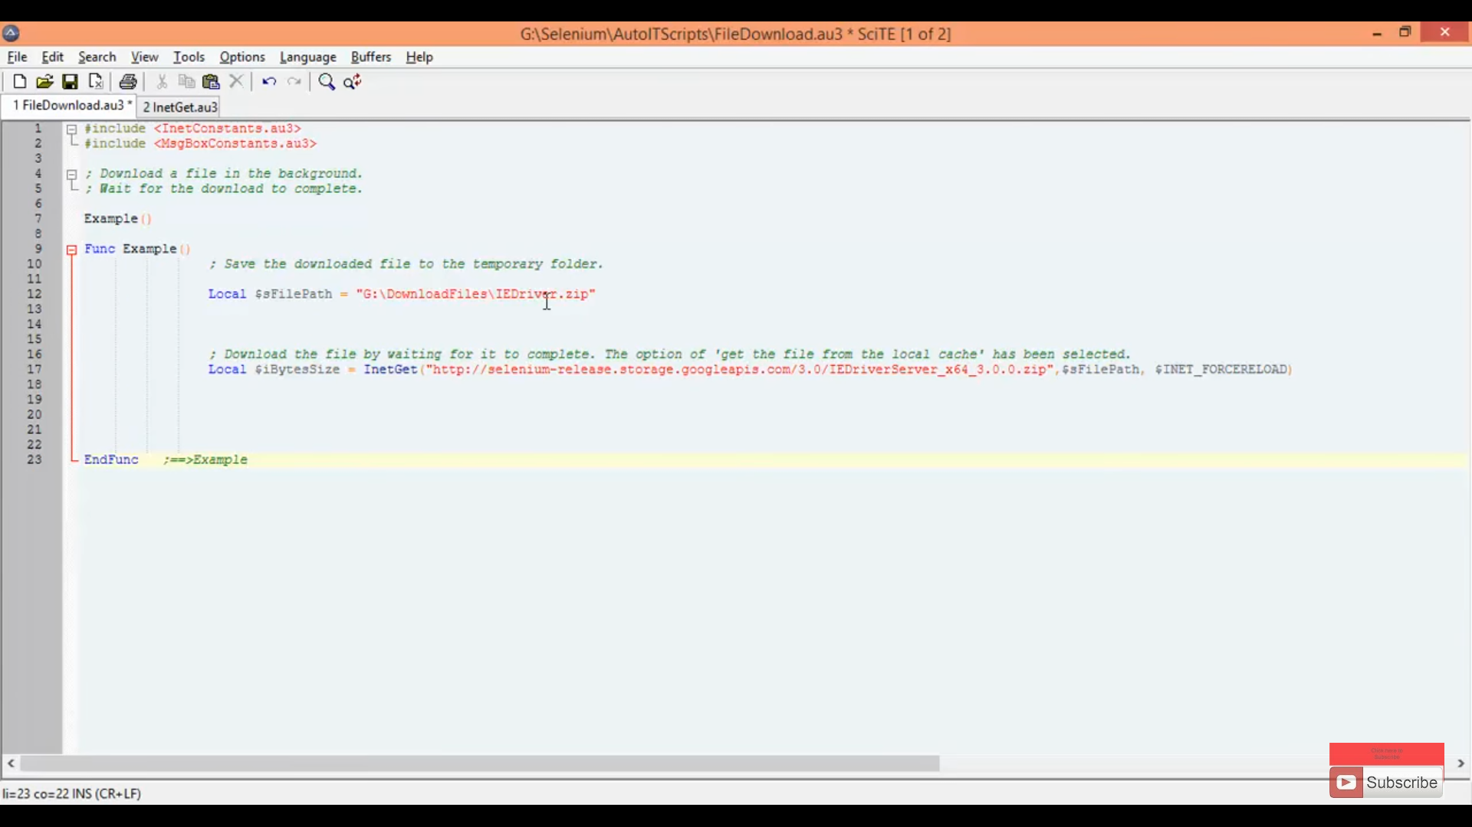

Fifth screenshot explains, other options of file download. In this use last line to delete the downloaded file.

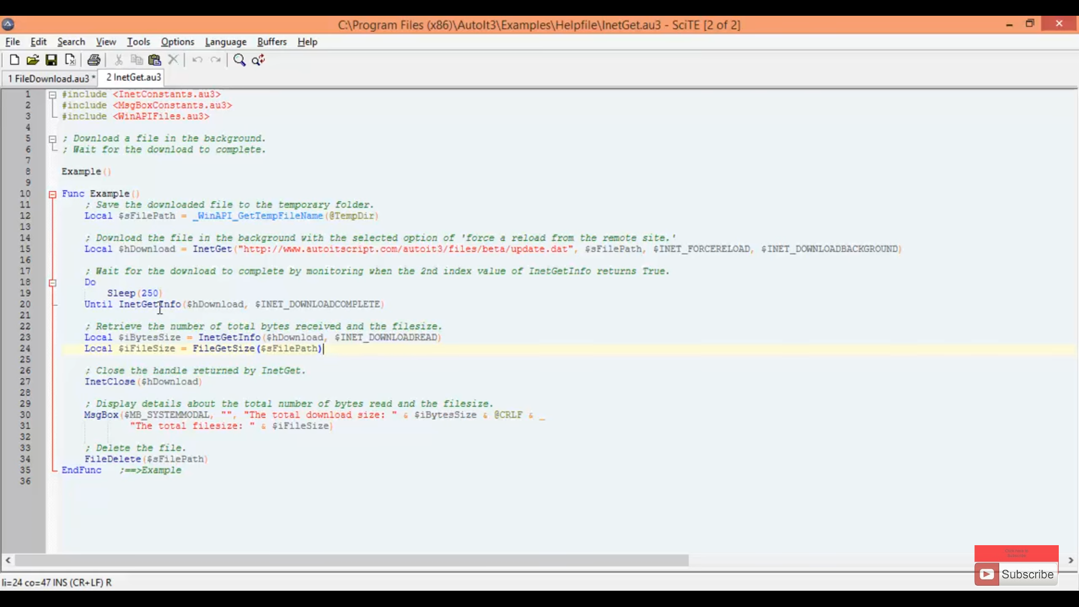

Sixth screenshot explains different tools to handle windows windows. Robot and Sikuli are best tools.

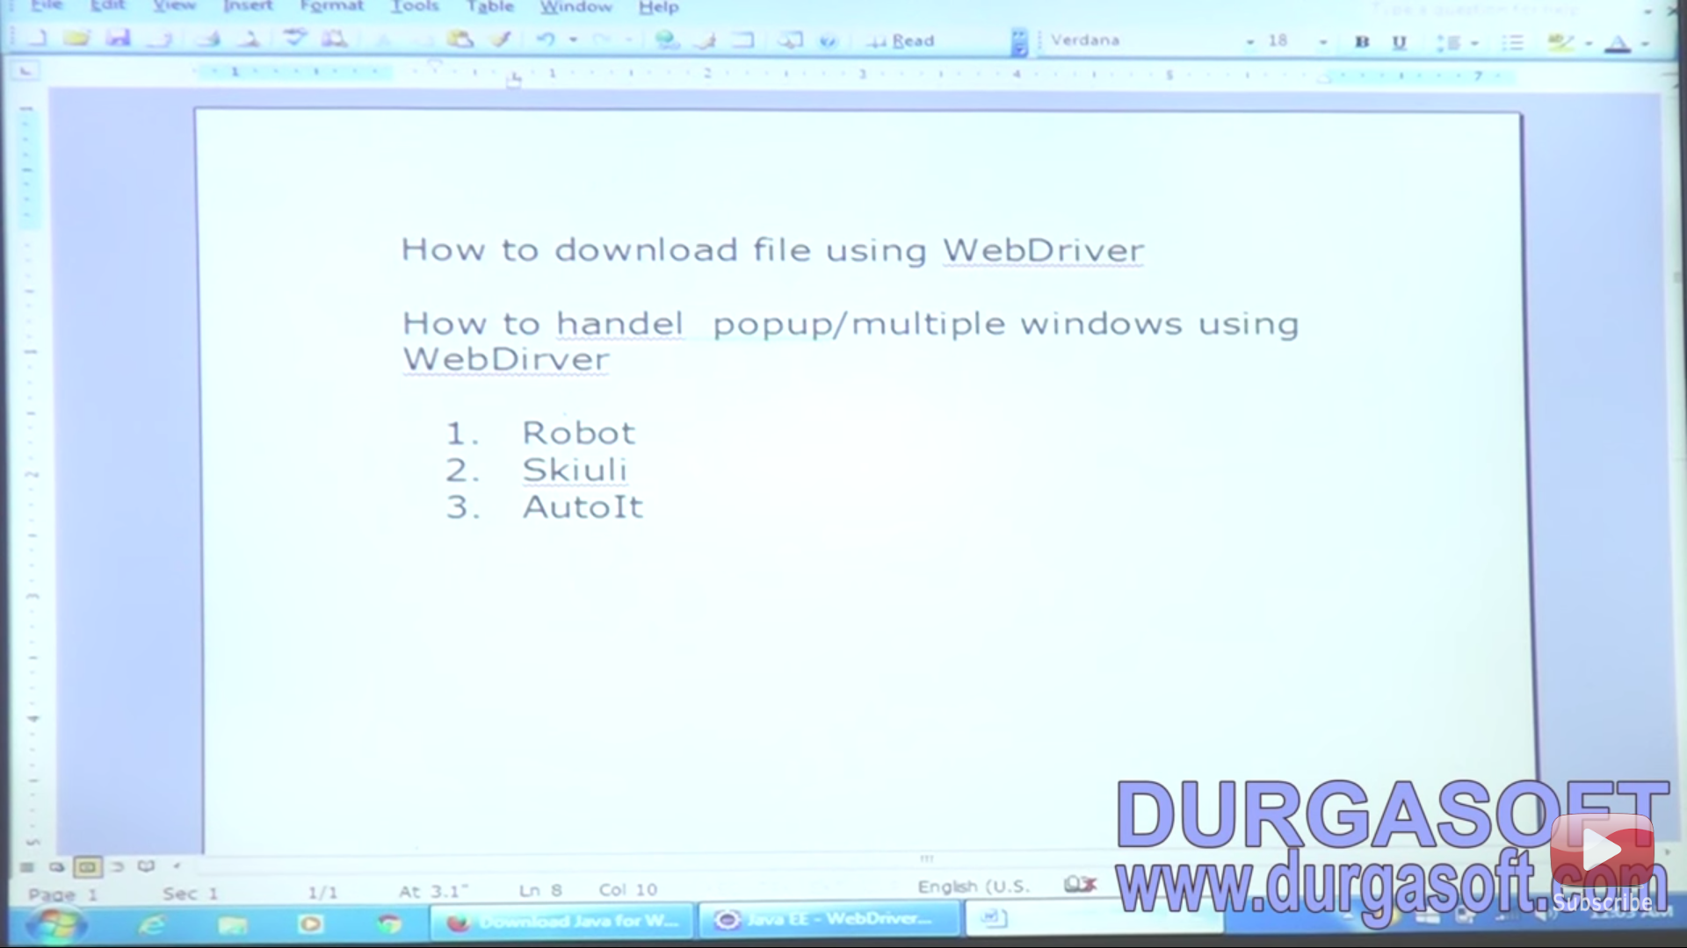

Seventh screenshot explains how to use Robot API from Java.awt and code to handle file download.

